Algebra II Chapter 5.1-5.4 Review Name__________________________________________Period______

Show all work. All answers must be in reduced Radical/Exponential Form.

You may use a four function calculator.

Simplify.

1.  2.  3. 

4.  5.  6. 

7.  8.  9. 

10.  11.  12. 

13.  14. (-32) 15. 

16.  17.  18. 

19.  20.  21. 

Solve. Show that you have checked your work. Watch for extraneous solutions.

22.  23.  24. 

25.  26.  27. 

Graph. Find at least 4 points. Identify domain and range.

28.  29. 

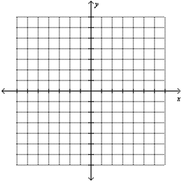

Write an equation for the graph.

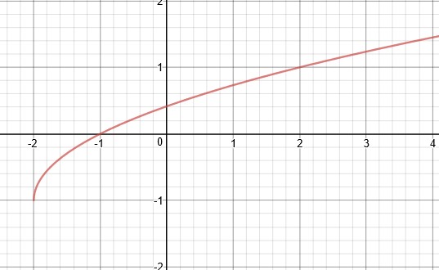 30.

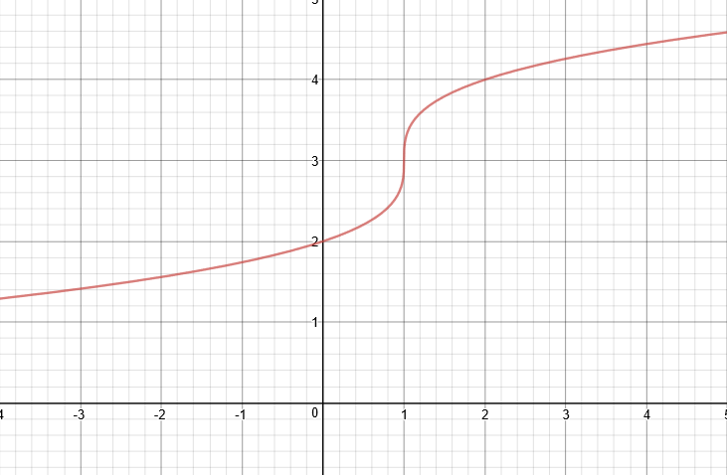 31.